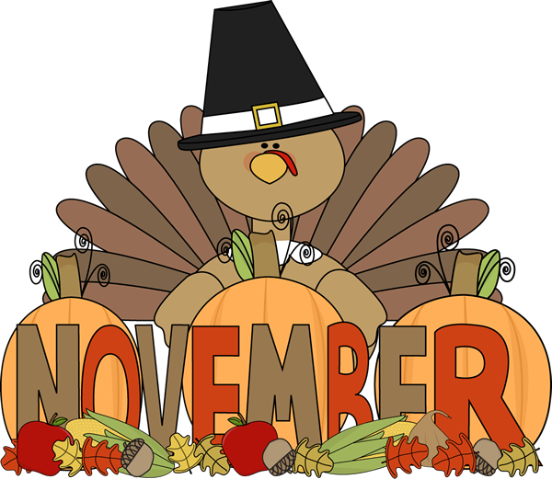
English Language Arts  Reading  This month our classes will launch into a world of nonfiction text.  Our unit is called Reading the Weather, Reading the World. Students will have the opportunity to explore nonfiction texts on their levels in various topics. They will learn to collect and organize information and transform it into a research project.  **Please make sure your child is reading for 30 minutes every night and recording it in their reading log  Writing  During our writing workshop, we will begin writing a personal persuasive essay.  Students will come up with a strong these by thinking about life issues that come up in their own personal lives and in stories they have read. They will support their thesis with various reasons and examples. | Math  We will be completing the unit on multiplication of 1-digit numbers and move onto multiplying by 2-digit numbers.  Word problems are an important part of our curriculum! We use the Problem Solving steps as a tool to help guide the students through the word problems
Content  Social Studies  Students are finishing up learning about Native American daily life. They’ve learned about the North Eastern Woodland Tribes, and will begin to move onto the next unit which teaches about the First Explorers.  Science  Students continue to learn about Energy Conservations and will be moving into learning about vision and light. | Important Dates  Nov 2- Fall Dance  Nov 6 – Election day - NO SCHOOL  Nov 12- Veterans Day NO SCHOOL  Nov 15- Report Cards – Parent Teacher Conference Half Day for all students  Nov 22-23 – Thanksgiving Recess – NO SCHOOL

Fourth Grade Newsletter

